***Screenshots of E-Circuits of Direct Connections.***

*1. ON - ON.*

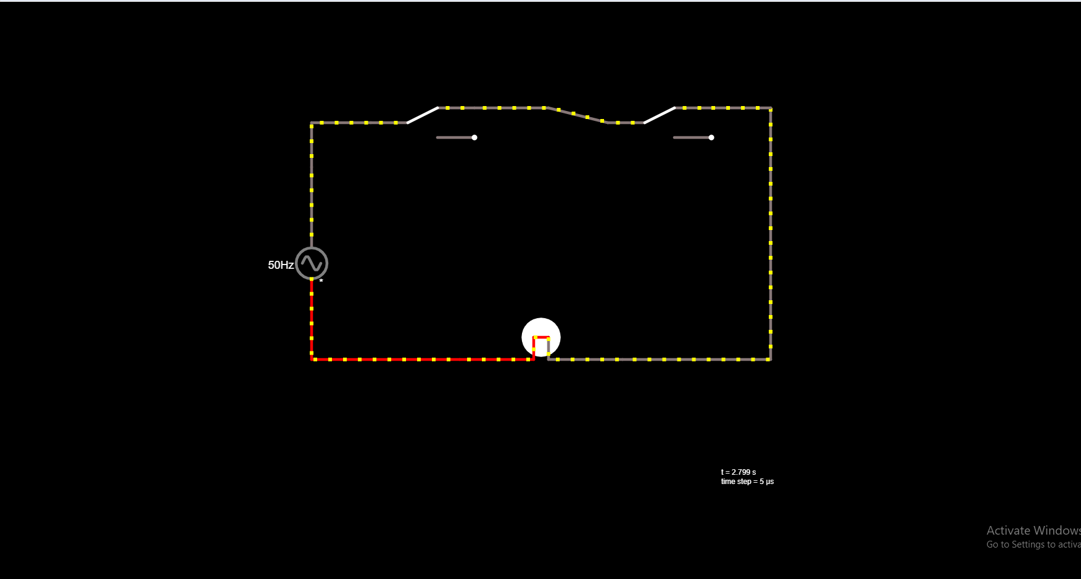

*2. OFF - ON.*

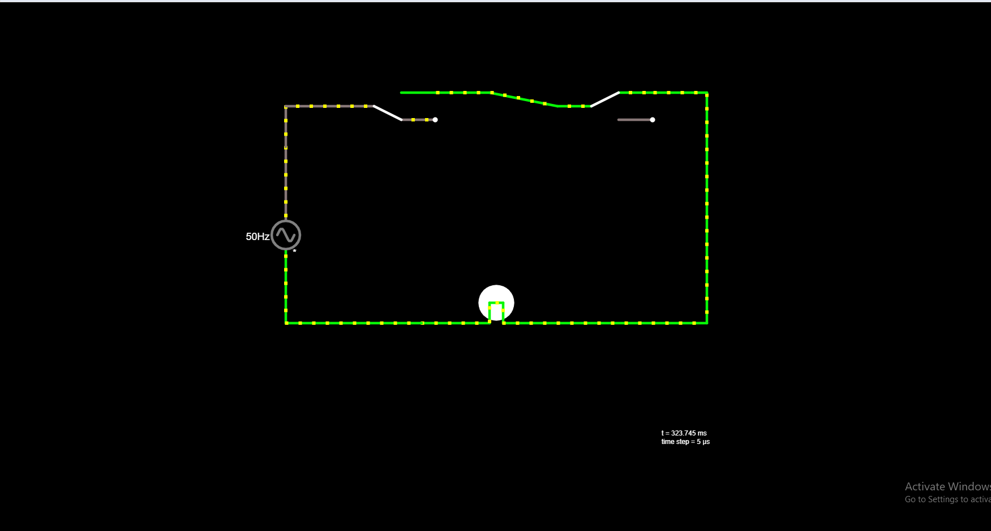

*3. ON – OFF.*

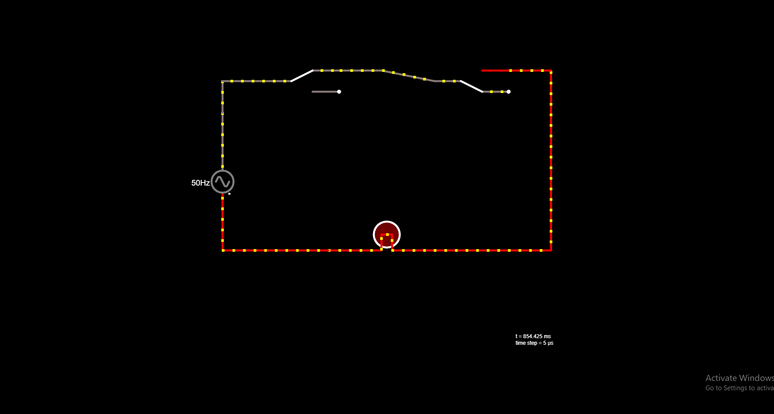

*4. OFF – OFF.*

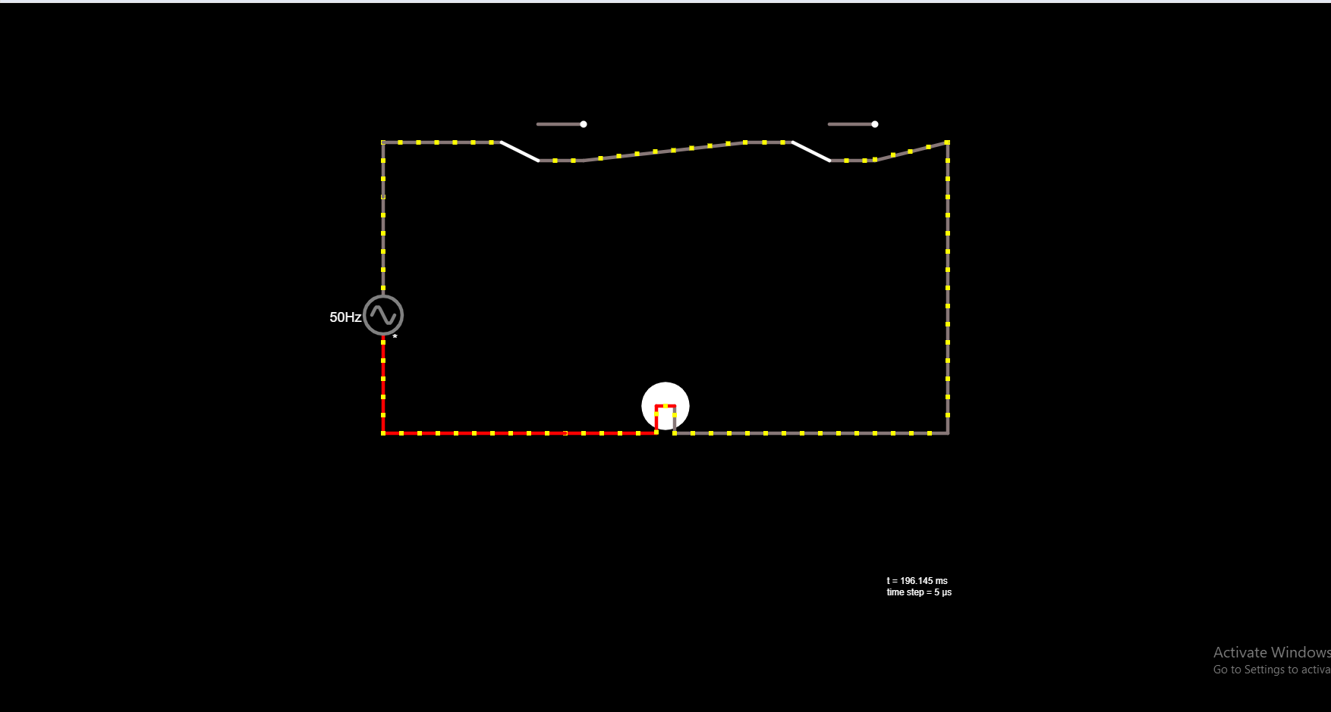

***Screenshots of E-Circuits of Cross Connections.***

*1. ON - ON.*

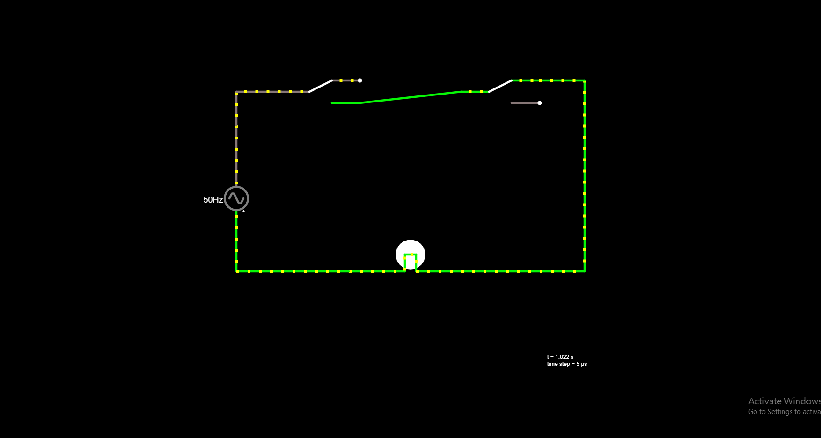

*2. OFF - ON.*

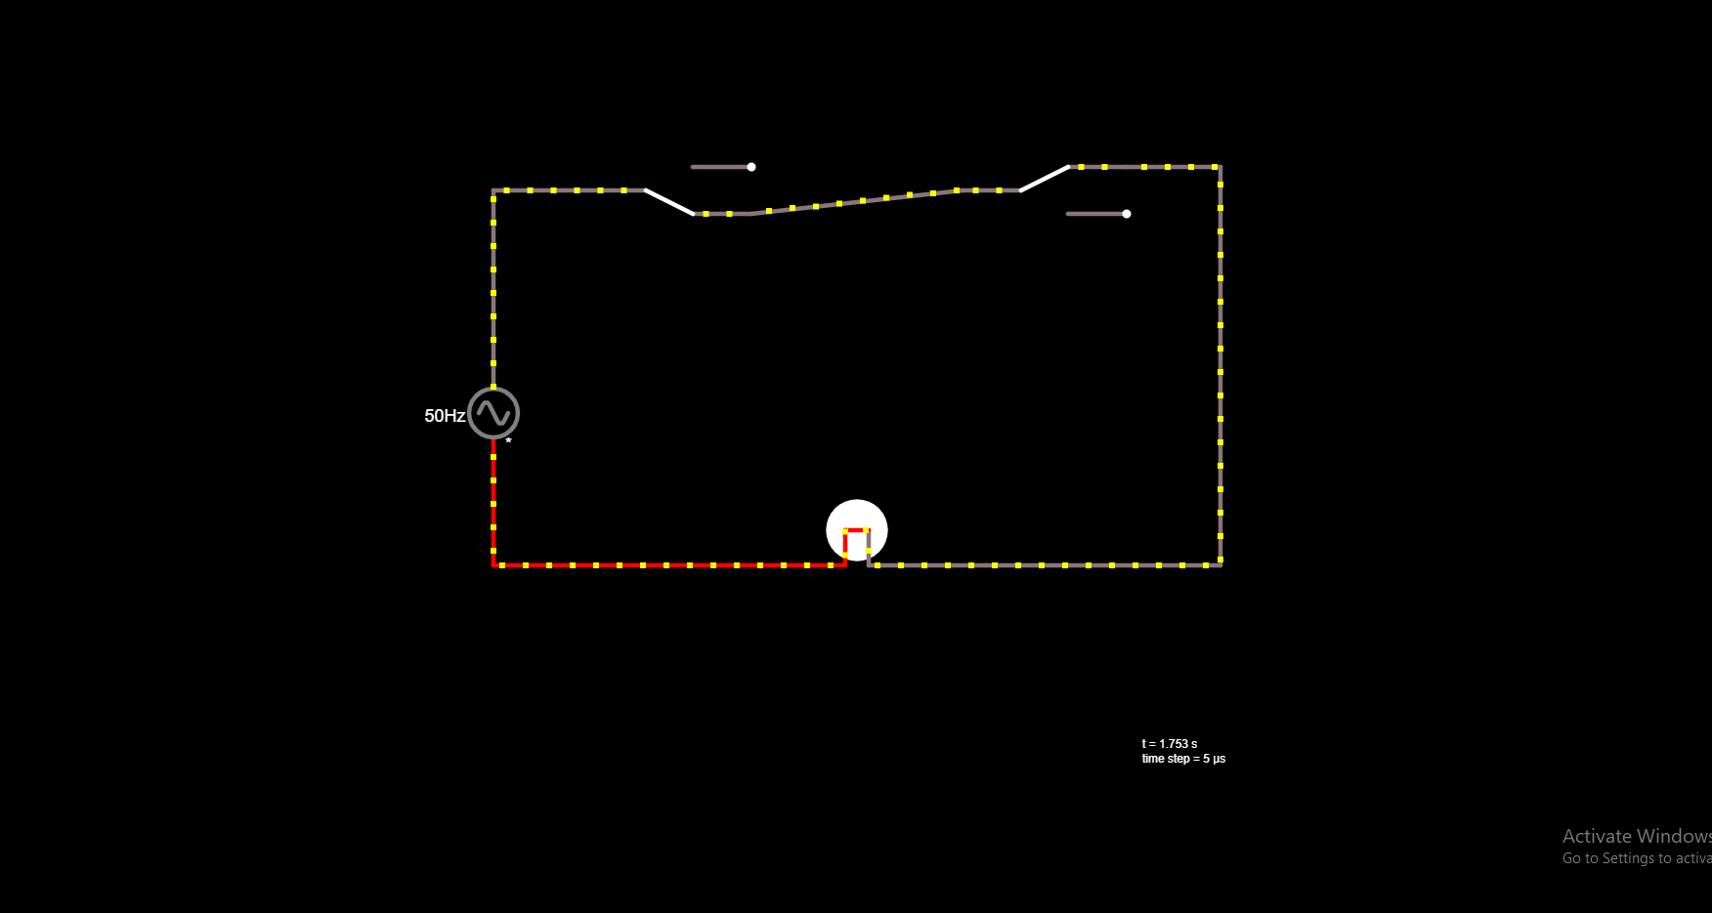

*3. ON – OFF.*

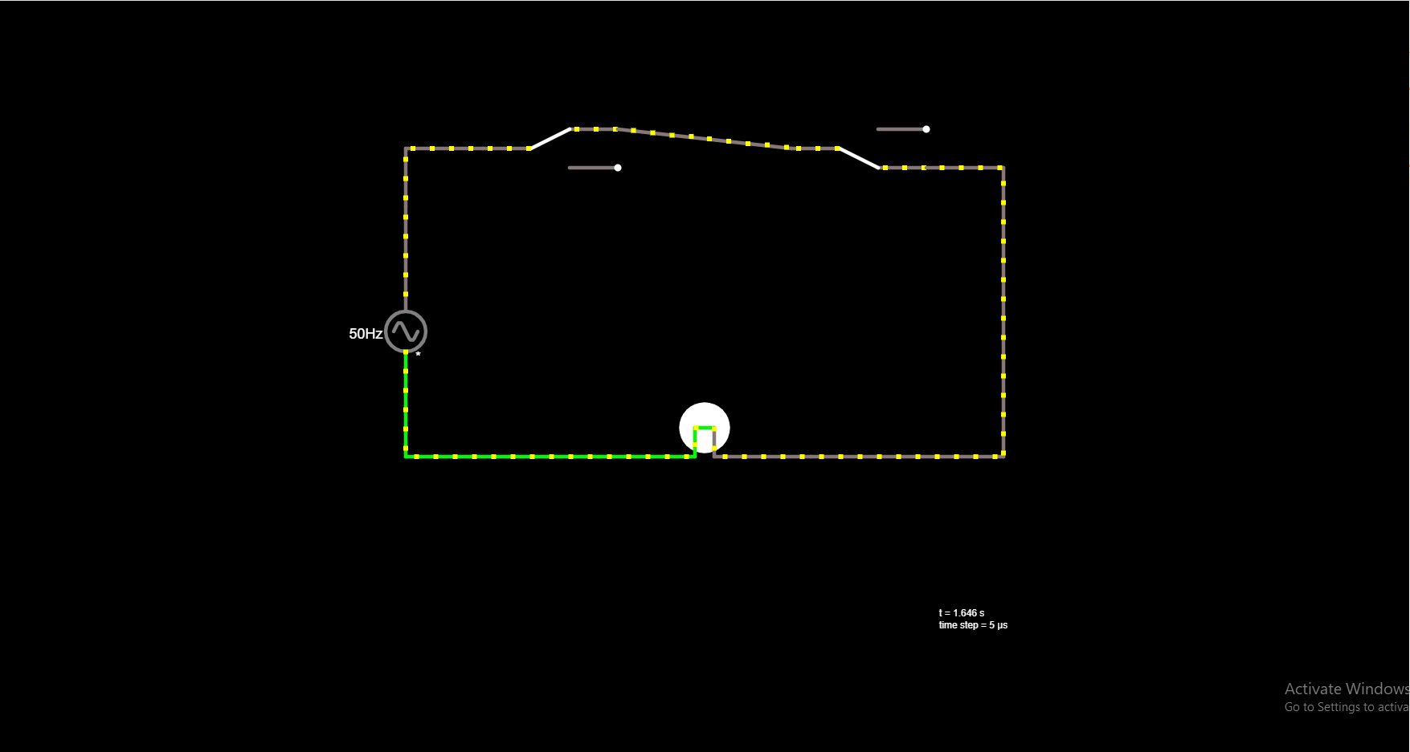

*4. OFF – OFF.*

